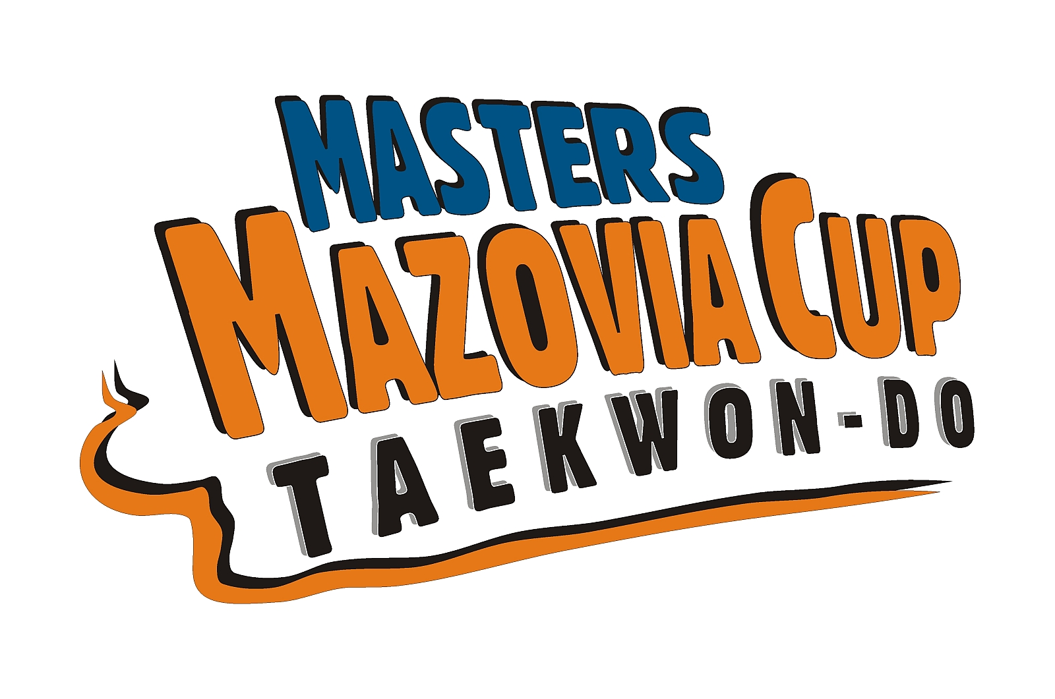
Invitation
Vth International Tournament Taekwon-Do
Masters Mazovia Cup 2011
- Main Sponsor:
  - Ciechanow Toun Council
- Support Sponsor:
  - Polish Cooperative Bank in Ciechanow
  - „Skan” Przasnysz Company
- Honorary patronage:
  - Mr. Waldemar Wardziński – President of Ciechanów.
- Aim:
  - Promotion of Taekwon-do
  - Promotion of Ciechanow City and Mazovia Area in Poland and abroad.
- Organizer:
  - LKS Matsogi Ciechanów,
- Co-organzier:
  - Polish Taekwon-Do Association.
  - MOSiR Ciechanów.
- Date:
  - 26th November 2011r.
- Weigh in and registration:
  - MOSiR Sports Hall in Ciechanow 17-go Stycznia 60 Street
- Venue of the competition:
  - MOSiR Sports Hall in Ciechanow, 17-go Stycznia 60 Street
SENIOR
BLACK BELTS
( born in 1993 and older)
Female
- Female pattern I- III dan
- Female pattern IV dan- VI dan
- Individual female sparring: -52 kg. -58. -63 kg.-70 kg. +70 kg.
- Special techniques ( only twimyo nopi ap cha busigi)
Male
- Male pattern I- III dan
- Male pattern IV-VI dan
- Individual male sparring: 54 kg. -63 kg.-71 kg. -80kg. +80 kg.
- Special Techniques ( tylko twimyo nopi ap cha busigi, twimyo nopi yop cha jirugi)

Team sparring black belts, team consist of 3 to 8 members, 1 female obligatory

SENIOR
COLOUR BEKLTS ( 6-1 kup)
( born in 1993 and older)

Female
- Female pattern 6 – 1 kup
- Individual Female Sparring: -52 kg. -58. -63 kg.-70 kg. +70 kg.
- Special Techniques ( only twimyo nopi ap cha busigi)
Male
- Male sparring 6 – 1 kup
- Individual Male sparring: 54 kg. -63 kg.-71 kg. -80kg. +80 kg.
- Special Techniques ( only twimyo nopi ap cha busigi, twimyo nopi yop cha jirugi)

Team sparring colour belts, team consists of 3 to 8 members, 1 female obligatory

JUNIORS
4 kup – III dan
( born in 1997 -1994)

Junior female
- Female junior pattern 4 kup- 1 kup
- Female junior pattern I - III dan
- Individual female sparring (4 kup – III dan): -45 kg. 50 kg. 55 kg. -60 kg. +60 kg.
- Special techniques ( only twimyo nopi ap cha busigi)
Junior male
- Male junior pattern 4 kup- 1 kup
- Male junior pattern I dan- III dan
- Individual Male junior sparring (4 kup – III dan): 52 kg. -58kg. -63 kg. -70kg. +70 kg.
- Special techniques ( only twimyo nopi ap cha busigi, twimyo nopi yop cha jirugi)

Team junior sparring 4 kup- III dan, team consists of 3 to 8 members, 1 female obligatory

COMPETITION RULES

The championships will be played according to the rules of ITF and PTA
Patterns:
- The competition is played in the traditional „pyramid system”
- During the eliminations competitors perform only one optional pattern, whereas at semi-finals and finals two patterns: optional and designated.
Individual Sparring:
- Sparring in each group is played in repasaże system
- Senior black belts- 2x2min ( repasage 1x2 min), juniors and seniors colour belts 1x3 min( repasage 1x1,30)
Team Sparring:
- The competition is played in the traditional „pyramid system”
- Team shall consist of 3 to 8 members including 1-2 females, females fights with females
- The Winner is the team who first get 6 points, seniors 1x2 min, juniors 1x1,30

REWARDS MMC

- Financial rewards for clubs in General medal classification
- Financial awards for athletes competing Turing Final Gala MMC
- Medals for I, II, i 2 x III places in patterns and individual sparring
- Medals for I, II, III place special techniques and team sparring
- Cups for clubs for I, II, III places in general medal classification

CONDITIONS OF PARTICIPATION
Entry fee :
- Seniors - 25 Euro per competitor
- Juniors - 15 Euro per competitor
- Team - 40 Euro per team

In MMC may participate only competitors:
- Members of ITF or PTA having min. 4 kup juniors and 6 kup seniors
- Having valid insurance
- Organizer has the right to Take additional 20 Euro for each competitor enrolled after deadline and for each change in an application
- Competitors participating in teams have to pay entry fee as well
- Each club bringing 5 competitors shall bring one referee
- In case of the Lack of referee club pays the fine in the Mount of 50 Euro

ACCOMMODATION
Hotel „Baron” Śląska 11, Street about 700 meters from the Sports Hall and Hotel „Olimpijski” 17-go Stycznia 60 Street
- triple and quadruple rooms - 25 Euro per person per night.
- double room - 35 Euro per person per night.
- Single room - 45 Euro od osoby za dobę.
The prices include breakfast and dinner.
There is a possibility to buy lunch in the amount about 5 Euro at the restaurant Olimpijski Hotel (nearby the Sports Hall).

SCHEDULE
25th November 2011 r. (Friday)
from 16.00 - teams arrival, lodging
16.00 - 20.00 - weigh in and registration- MOSiR Sports Hall
20.30 - 21.00 - Coach meeting- MOSiR
21.00 - 21.30 - Umpire Meeting
26th November 2010 r. (Saturday)
07.00 - 8.00 - breakfast
8.00-9.00 - weigh in
9.00- 17.00 - competition
17.00-18.30 - break
19.00- 20.30 - Final Gala Taekwon-do MMC 2011
21.00 - banquet
OTHER MATTERS
- The competitors have to be in possession of safety equipment in accordance with PTA and ITF rules
- Junior must wear head guard
- There must be min. 4 competitors in each category/ division. In case if there are less than
4 competitors in category, the Organizer has right to cancel the category.
- Clubs are not allowed to combine
- The Chairman of the Competition or the Organizer decide about the matters not written in this announcement.
APPLICATIONS:
Deadline of sending applications is
30th October 2011 r. into:mkorzybski@wp.pl and info@pztkd.lublin.pl
Looking forward to seeing you in Ciechanow!

Organizer
Michał Korzybski V dan
